Patrons
Dr.T.R.Parivendhar, Chancellor
Mr. Ravi Pachamoothoo, Chairman
Dr.P.Sathyanarayanan, President
Dr.R.Shivakumar, Vice President

Advisory Committee
Dr.Prabhir K Bagchi, Vice Chancellor
Dr.T.P.Ganesan, Pro-VC
Dr.N.Sethuraman, Registrar
Dr.C.Muthamizhchelvan, Director (E&T)
Dr. D. Narayana Rao, Director (Research)
Dr.S.V.Kasmir Raja, Dean (Research)
Dr. B. Amutha, Professor & Head, CSE Dept
Dr. S.S. Sridhar, Professor
Dr. S.Prabhakaran, Professor

Convener
Dr. E .Poovammal Professor, CSE
Co - Convener
Dr. C.Malathy Professor , CSE

Functional Committee
Mr.M.Eliazer, AP/CSE
Mrs.R.Vidhya, AP/CSE
Mrs.S.Priya, AP/CSE
Mrs.C.Jayavarthini, AP/CSE
Mrs.B.Ida Seraphim, AP/CSE
Mrs.S.Poornima, AP/CSE
Mrs.B.Sowmiya, AP/CSE
Mrs.R.Subash, AP/CSE
Mrs.S.S Saranya, AP/CSE
Mrs.A.Meenapriyadharshini, AP/CSE
Mrs.J.Jayapradha, AP/CSE
Mrs.J.Prathipa, AP/CSE
Ms.P.Mahalakshmi, AP/CSE
Mrs.R.Radha, AP/CSE
Mrs.D.Viji, AP/CSE

Registration Details
To register for the workshop,
Kindly fill the form at
http://www.srmuniv.ac.in/events/cse/nwbat17
Registration confirmation will be sent by email.
Payment Details ( DD / NEFT/IMPS Transfer)
Bank : Indian Bank
Branch : SRM University
Acc. Name : COMPUTER SCIENCE&ENG ASSO
Acc. No : 459777790
IFSC Code : IDIB000M122
Registration Fee
Industrial Personnel Rs. 3000
Faculty Rs. 2500
Research Scholars, Students Rs. 2000
Registration fee per day Rs.800
The registration fee includes the Workshop Kit, lunch and refreshments. The number of seats is limited and t participants will be chosen on first-come-first-served basis.
Accommodation
Boarding /Lodging facilities will be provided on request (two days in advance) for outstation participants in the hostel / guest room. No TA/DA will be given.

Note: The Bank DD shall be drawn in favor of “COMPUTER SCIENCE & ENG ASSO”, payable at Chennai.
Important Date
Last date for Registration : 2nd Feb 2017

ADDRESS FOR COMMUNICATION
The Convenor, NWBAT2017
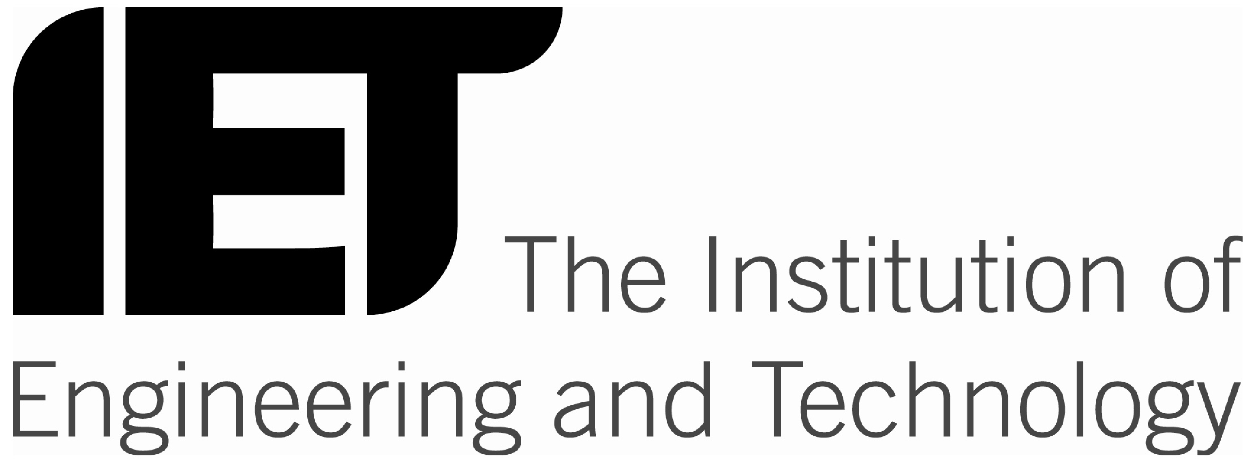
Department of Computer Science and Engineering,
SRM University, Kattankulathur,
Kancheepuram (Dt.) Tamil Nadu, India,
Pin: 603203. Ph: 044-27417820
http://www.srmuniv.ac.in/events/cse/nwbat17
nwbat17@gmail.com

National Workshop

On

“Big Data Analytics Tools
NWBAT 2017”

23rd-27th February 2017

Organized by:

Department of Computer Science & Engineering Faculty of Engineering & Technology

SRM University

In Association with

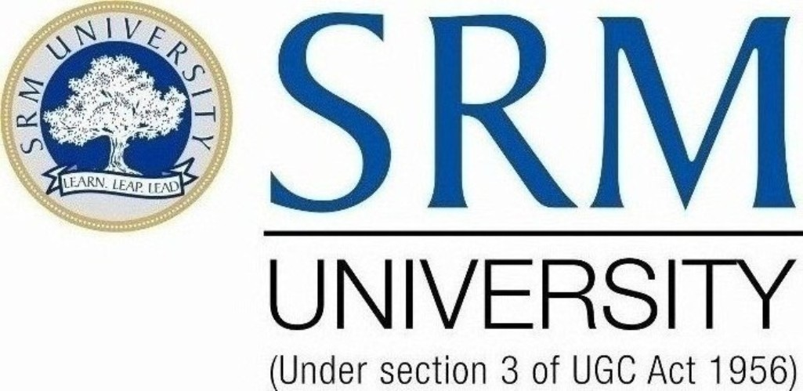

About the University
SRM University is one of the top ranking universities in India with over 38,000 students and more than 2600 faculty across all the campus, offering a wide range of undergraduate, postgraduate and doctoral programs in Engineering, Management, Medicine and Health sciences, and Science and Humanities.

About the Department of Computer Science and Engineering
The Department of Computer Science and Engineering offers B.Tech, M.Tech and PhD. The Department has been accredited by NAAC. It has exce llent Infrastructure facilities with High end systems networked with fiber optic backbone. Internet and Wi-Fi facilities are provided for both faculty and students. Well qualified & experienced faculty form the backbone of the department. Special Interest Groups (SIG) in the department carry out research activities in various fields like Software Defined Networking, Image processing & pattern recognition, Data mining, Neural Networks, Bio Metrics, Wireless Sensor Networks, Mobile Adhoc Networks, Machine Learning etc.

ABOUT THE WORKSHOP

Big data analytics helps organizations harness their data and use it to identify new opportunities. That, in turn, leads to smarter business moves, more efficient operations, higher profits and happier customers.Big data technologies such as Hadoop and cloud-based analytics bring significant cost advantages when it comes to storing large amounts of data – plus they can identify more efficient ways of doing business.With the speed of Hadoop and in-memory analytics, combined with the ability to analyze new sources of data, businesses are able to analyze information immediately – and make decisions based on what they’ve learned.With the ability to gauge customer needs and satisfaction through analytics comes the power to give customers what they want. Davenport points out that with big data analytics, more companies are creating new products to meet customers’ needs.

RESOURCE PERSONS

Mr.Joy Mustafi
Principal Applied Scientist @ Microsoft
Data Science and Machine Learning
Hyderabad Area, India

Dr. E. Poovammal
Professor
Department of Computer Science and Engineering,
Kattankulathur Campus, SRM University.
Dr. Rudra Prakash Pradhan
Associate Professor,
IIT Kharagpur

Mr.K. Vijay Kumar
Senior Engineer, C-DAC, Chennai

Dr.S.Geetha,
Professor,
Dept.Ofcse,V.I.T. UNIVERSITY
Dr.Padi.TirupathiRao
Professor
Pondicherry University
Dr.V.Pattabiraman
Associate Professor,
Dept.Ofcse,V.I.T. UNIVERSITY
RituparnaSen
Assistant Professor
Indian Statistical Institute
Chennai, India

Contact Persons
Mrs.Jayapradha.J AP / CSE
+91 8754406831
Mrs. D.Viji, AP / CSE
+91 9043784275

Workshop Outcomes

By the end of this workshop, participants will be able to,
- Installation and Basic in R Programming
- Volatility Modelling
- Case Study in CDAC
- Tentative
- Tentative
- Statistical Datamodelling mining with R-Programming
- Integrating R with TABLAU and Data Modelling.
- Dimensionality Reduction and Multivariant Analysis.

